## Lab Task No # 8

**2024**

## CS-205 Lab

Submitted by: **Syed Muhammad Naqi Raza**

Registration No: **2022574**

Faculty: **Cyber Security**

**“On my honor, as student of Ghulam Ishaq Khan Institute of Engineering Sciences and**

**Technology, I have neither given nor received unauthorized assistance on this academic work.”**

Submitted to:

## Mam Marwa Bibi

DATE: **17/4/2024**

* **Create a New Repository**

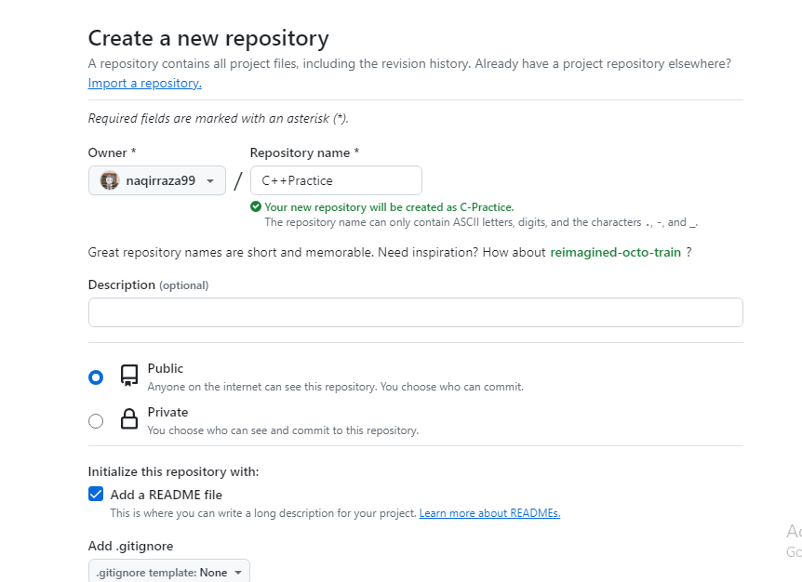

* **Clone the Repository**
* 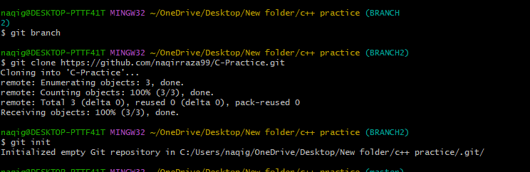
* **Add Files in a Repository**

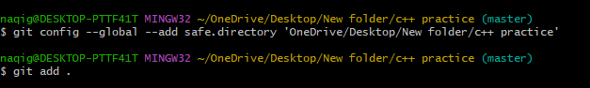

* **Commit the Changes**

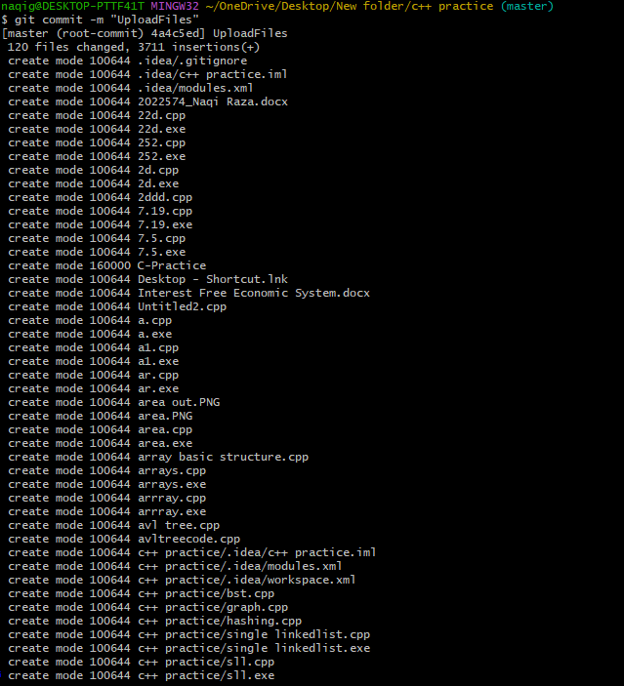

* **Create a New Branch**

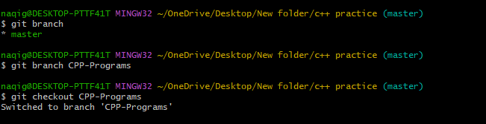

* **Push Code to the new branch**

* **All the configurations setting of git on the local computer**

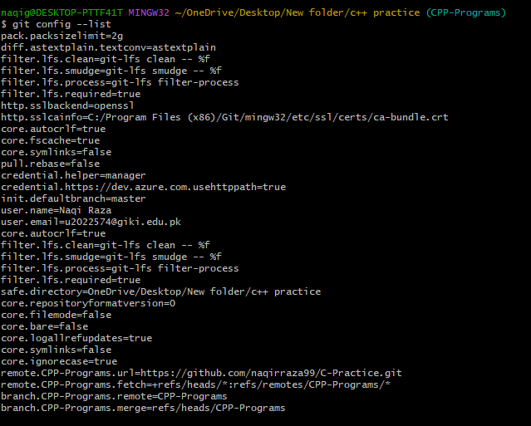

* **To see locally the history of git commits**

* **Code Pushed to the GitHub Repository**

